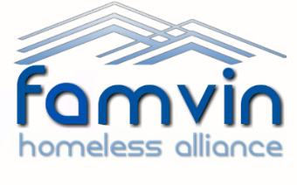
FHA Ambassador Application Form
Thank you for your interest. Please return this form to fha.info@famvin.org – use the subject ‘Ambassador Application – YOUR NAME’

Name:

Country:

Vincentian branch:

Email:

Phone number:

Languages spoken:

Date of birth:

- Why do you want to be an FHA Ambassador? (300 words max)

- Please describe your current involvement in the Vincentian Family? How did you hear about the Ambassador Program? (200 words max)

- Please describe your involvement in helping homeless people? (200 words max)

- Please describe your experience of public speaking? (200 words max)

- Please describe how you use social media? (100 words max)

- What do you hope to learn and gain from being an FHA Ambassador? (200 words max)

I have read, understand and agree to the ‘Ambassador Commitments’ detailed on the FHA website.

